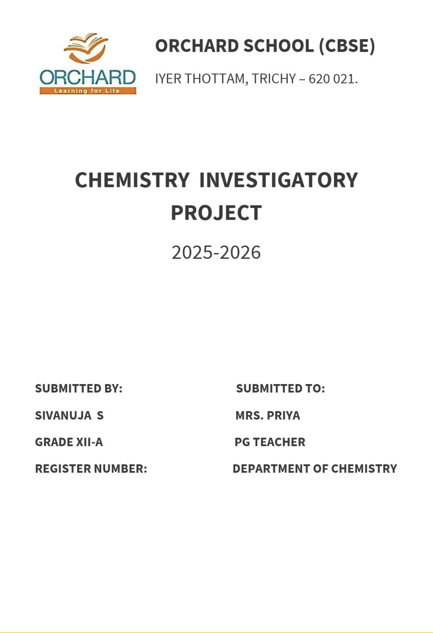

Declaration

I hereby declare that the project work entitled, “Foaming Capacity of Soap. ”, Submitted to the DEPARTMENT OF CHEMISTRY, Orchard school is carried out by me. This work has not been submitted earlier in full or in part.

Sivanuja .S

Acknowledgement

I would like to express our special thanks of gratitude to our school principal MRS.SILVIE NESA as well as to our Chemistry teacher MRS.PRIYA who gave the golden opportunity to do this wonderful project on this topic ‘FOAMING OF SOAP.’ which also helped me in a lot of research work and I came to know about so many new things. I am really thankful to them.

Sivanuja S

Certificate

This is to certify that, the bonafide record of project work done by SIVANUJA S of Grade 12 during the academic year 2025 – 2026. Submitted for AISSCES Chemistry Practical Examination held on _ ___/___/2025 at Orchard School (CBSE), Iyer Thottam, Trichy-21

Date:
Internal Examiner External Examiner

Principal

Index

S.no | Topic | Page Number
1 | Introduction | 1
2 | Experiment - 1 | 3
3 | Theory - 1 | 5
4 | Experiment - 2 | 6
5 | Theory – 2 | 7
6 | Conclusion | 11
8 | Bibliography | 13

Introduction

Soaps are sodium or potassium salts of higher fatty acids like stearic ,palmitic and oleic acids can be either saturated or unsaturated. They contain a long hydrocarbon chain of about 10- 20 carbon with one carboxylic acid group as the functional group. A soap molecule a tadpole shaped structure, whose ends have different polarities. At one end is the long hydrocarbon chain that is non-polar and hydrophobic, i.e., insoluble in water but oil soluble. At the other end is the short polar carboxylate ion which is hydrophilic i.e., water soluble but insolution.

When soap is shaken with water it becomes a soap solution that is colloidal in nature. Agitating it tends to concentrate the solution on the surface and causes foaming. This helps the soap molecules make a unimolecular film on the surface of water and to penetrate the fabric. The long non-polar end of a soap molecule that are
hydrophobic, gravitate towards and surround the dirt (fat or oil with dust absorbed in it). The short polar end containing the carboxylate ion, face the water away from the dirt and grease in a clustered structure called 'micelles', which encircles such particles and emulsify them.
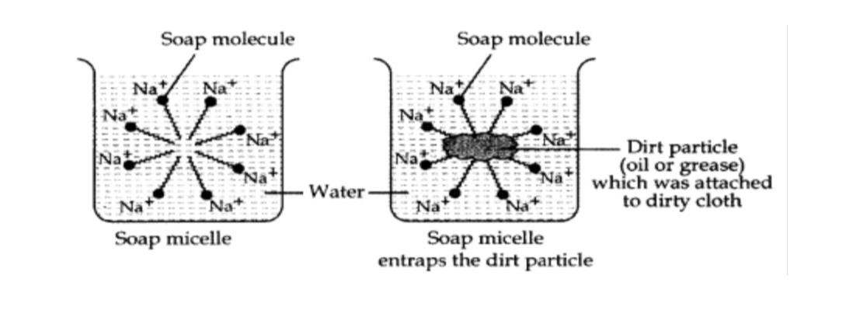
Cleansing action of soaps decreases in hard water. Hard water contains calcium and magnesium ions which react with sodium
carbonate to produce insoluble carbonates of higher fatty acids.
2C17H35COONa + Ca2+ → C17H35COO)2Ca + 2Na+
2C17H35COONa + Mg2+ → (C17H53COO)2Mg + 2Na+

This hardness can be removed by addition of Sodium Carbonate.
Ca2+ + Na2CO3 → CaCO3 + 2Na+

Mg2+ + Na2CO3 → MgCO3 + 2Na+

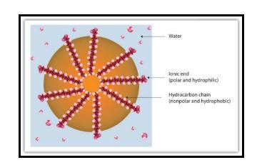

Experiment - 1

AIM :
To compare the foaming capacities of five different soaps

APPARATUS :
5 test tubes, 5 conical flasks(100ml), test tube stand,
Bunsen burner and stop watch.

MATERIALS REQUIRED :
5 different samples of soap and distilled water

THEORY :
The foaming capacity of soap sample depends upon the nature of soap and its concentration. This can be compared for various samples of soaps by taking the same concentration of solution and shaking them. The foam is formed and the time taken for disappearances of foam in all cases is compared. The lesser the time taken by asolution for disappearance of foam, the lower is its foaming capacity.

PROCEDURE :

- Five conical flask (100 ml each) are taken and numbered 1 to 5
- In each of these flasks equal amount (say 5 gm) of the given samples of soap shavings or granules are taken and 50ml of distilled water is added.
- Each conical flask is heated few minutes to dissolve all the soap completely.
- In a test tube stand, five big clean and dry test tubes are taken and numbered 1 to 5
- One ml of the five soap solution is then poured in the test tubes of corresponding number.
- 10ml of distilled water is then added to each test tube
- Test tube no 1 is then shaken vigorously 5 times.
- The foam would be formed in the empty space above the container. Stop watch is started immediately and the time taken for the disappearance is noted • Similarly the other test tubes are shaken well for equal number of times ( i.e.-5 times) with approximately with the same force and the time taken for the disappearance of foam in each case is recorded
- The lesser the time taken for the disappearance of foam, lower is its foaming capacity

OBSERVATION :
1 | Amount of each sample taken | 5gm
2 | Amount of distilled water taken | 50gm
3 | Volume of each soap taken | 1ml
4 | Volume of distilled water added | 10ml

S.NO | SOAP SAMPLE | TIME TAKEN(min)
1 | Dettol | 10
2 | Lux | 15
3 | No – 1 | 20
4 | Breeze | 23
5 | Lifebuoy | 25

CONCLUSIONS :
The soap for which the time taken for the disappearance of foam is highest has maximum foaming capacity and is the best quality soap among the soaps tested

Experiment - 2

AIM :
Study the effect of the addition of Sodium Carbonate (Washing Soda) on the foaming capacity of different soap Solutions.

APPARATUS :
3 test tubes, test tube stand, Bunsen burner and stop watch.

MATERIALS REQUIRED :
5 gm sample of soap, tap water and M/10 Na2CO3 solution.

THEORY :
When sodium or potassium soaps are put into water containing calcium and magnesium ions (Hard water), results in formation of scum which applies grey appearance on the cloth. To achieve the same washing or cleaning action, more soap must be added.

2C17H35COONa + Ca2+ → C17H35COO)2Ca + 2Na+

Hard water is water that has high mineral content (mainly calcium and magnesium ions) (in contrast with soft water ) . Hard water minerals primarily consist of calcium (Ca2+), and magnesium (Mg2+) metal cations, and sometimes other dissolved compounds such as bicarbonates and sulphates. Calcium usually enters the water as either calcium carbonate (CaCO3), in the form of limestone and chalk, or calcium sulphate (CaSO4), in the form of other mineral deposits.

When Na2CO3 is added to tap water the calcium (Ca2+), and magnesium (Mg2+) ions precipitate as their carbonates .i.e . foaming capacity of soap increases.

Ca2+ + Na2CO3 → CaCO3 + 2Na+

Mg2+ + Na2CO3 → MgCO3 + 2Na

PROCEDURE :
- Dissolve 5 gm of soap and dissolve it in 50 ml of tap water.
- Add 5 ml of M/10 sodium carbonate to all three test tube
- To above test tubes add soap solutions separately
- Then 5 ml of water is added to the three test tubes
- Now shake first test tube for formation of foam
- Now start the stop watch to calculate time taken for disappearance of foam.
- Similarly, perform the experiment with other soap solutions. Record the observations in a tabular form.

OBSERVATION :

•Amount of each soap sample taken = 5 gm
•Amount of tap water taken = 50 ml
•Volume of each soap solution taken = 1 ml
•Volume of tap water added = 5 ml
•Volume of M/10 sodium carbonate added= 5 ml

S.NO | SOAP SAMPLE | TIME TAKEN (min)
1 | Dettol | 26.30
2 | Life buoy | 11.5
3 | Savalon | 24.20

CONCLUSION :
The soap for which the time taken for the disappearance of foam is highest has maximum foaming capacity and is the best quality soap among the soaps tested.

Conclusion

From the above experiments it can be inferred that the foaming capacity of a soap increases when it is added in soft water (Containing M/10 Sodium Carbonate). This means that cleaning property of soap is better in soft water compared to its cleaning property in hard water.

BIBLIOGRAPHY

Together With Lab Manual Chemistry – XII —
(Publisher details in your lab manual).
(Cited for experimental techniques and lab procedure.)
CBSE

NCERT Chemistry Textbook for Class 12 —
Chapter on Surface Chemistry / Soaps & Detergents.
(Basic theory of soap molecules, micelle formation, and foam properties.)

“Chemistry Project to Compare the Foaming Capacity of Soaps”, CBSE.
Available at: https://www.icbse.com/projects/chemistry-project-to-compare-the-foaming-capacity-of-soaps-6ng
(Provides experimental procedure and concept explanation.)
iCBSE

“Chemistry Project on Foaming Capacity of Soaps”, CBSE.

